System Requirements Statement (SRS) –
Job-Bridge System

Doc. Ref. :
Version :
Status :
Created by :
Date :

1. Introduction 3
2. Functional Requirements 4
2.1 Job Seeker Module 5
2.2 Employer Module 11
2.3 admin Module 16
2.4 Use Case Diagram..................................................................................................................... 20

THIS DOCUMENT CONTAINS 20 NUMBERED PAGES

Introduction

1.1 Purpose
This document explains the system requirements and overall scope for developing the Job Bridge System. It specifies the functional requirements, system behaviour, operational constraints, business objectives, and key expectations required to design a reliable, efficient, scalable, and user-friendly web-based job portal that effectively connects job seekers with employers and supports a structured recruitment process.

1.2 Scope
The Job Bridge System is a proposed web-based application that aims to provide a single, centralized platform for job searching and recruitment. The system will allow job seekers to register, search for jobs, upload resumes, and apply for job opportunities, while employers will be able to post job openings and manage candidate applications. The system is intended to reduce manual recruitment efforts, improve transparency, and streamline the hiring process.
1.3 System Overview
The Job Bridge System is divided into the following main parts:
- Job Seeker Module
- Employer (Recruiter) Module
- Admin Module
This document describes the system requirements for all modules.

1.4 Definitions, Acronyms, and Abbreviations
This section defines the key terms and abbreviations used throughout this document to ensure a common understanding among all stakeholders.
- Job Bridge System: A proposed web-based job portal designed to connect job seekers and employers on a single platform.
- Job Seeker: A user who searches for job opportunities and applies for jobs through the system.
- Employer / Recruiter: A user who posts job openings and manages candidate applications.
- Administrator (Admin): A user responsible for managing system operations.

2.Functional Requirements

The Job Bridge System consists of three major modules, each of which is divided into multiple functional processes as described below :

No | SRS requirement ID | Description
2.1 | Job Seeker Module
2.1.1 | F1 | Account Creation Process
2.1.2 | F2 | Login Process
2.1.3 | F3 | Forgot Password Process
2.1.4 | F4 | Change Password Process
2.1.5 | F5 | Update Profile Process
2.1.6 | F6 | Resume Upload/Update Process
2.1.7 | F7 | Search Job Process
2.1.8 | F8 | View Job Details
2.1.9 | F9 | Apply for Job
2.1.10 | F10 | View Application Status And History
2.2 | Employer Module
2.2.1 | F11 | Employer Account Creation
2.2.2 | F12 | Login Process
2.2.3 | F13 | Forgot Password Process
2.2.4 | F14 | Change Password Process
2.2.5 | F15 | Update Company Process
2.2.6 | F16 | Post Job Opening
2.2.7 | F17 | Update Job Posting
2.2.8 | F18 | Delete Job Posting
2.2.9 | F19 | View Job Applications
2.2.10 | F20 | Shortlist / Reject Candidates
2.3 Admin Module
2.3.1 | F21 | Admin Login Process
2.3.2 | F22 | Forgot Password Process
2.3.3 | F23 | Change Password Process
2.3.4 | F24 | Update Account Management
2.3.5 | F25 | Approve / Reject Employer Accounts
2.3.6 | F26 | Monitor Job Postings
2.3.7 | F27 | Remove Invalid Job Posts
2.3.8 | F28 | Generate Reports
2.3.9 | F29 | Manage System Settings

Job Seeker Module
- A Job Seeker is a system user who searches for jobs and applies for job opportunities.
- The Job Seeker can create an account, manage profile information, upload resumes, and track job applications.

Account Creation Process

- The Job Bridge System requires a job seeker to create an account before using system features.
- The system shall provide an account creation function for job seekers.
- During account creation, the system shall collect the following information:
- Login information
- Contact Details
- The login information includes the following mandatory fields:
- User ID
- Password
- First Name
- Last Name
- Email address
- User Type
  - All items are mandatory
  - UserID
- The User ID must be unique.
- User IDs are case-insensitive.
- Duplicate User IDs are not allowed.
  - Password
- Password length must be between 8 and 16 characters.
- Password must include:

  - At least one numeric digit
  - At least one uppercase letter
  - At least one lowercase letter
  - At least one special character

- Password must be masked during entry.
- Password must be entered twice for confirmation.
- Password must be stored in encrypted form.
  - User Type
- The User Type option :
      - Job Seeker
      - Employer
      - Administrator
- During registration, the user can select Job Seeker only.
- Administrator accounts are predefined and cannot be selected.
- Personal Details
- The Personal Detail consists of some items described as below.
- Permanent Address
- Contact Phone No
  - All fields are mandatory.
  - Address selection may include predefined options such as state or city.

Login Process
- The Job Bridge System requires authentication before granting access.
- Authentication requires User ID and Password.
- The System validates login using the following checks :
  - User ID and Password must be correct.
  - User Type must be “Job Seeker”.
  - Account status must be active.
- If all checks pass, the user is redirected to the Job Seeker Home Page.
  - Finally, the User ID must be active and available.
  - The Administrator has the authority to enable or suspend user accounts as per system policies.
  - If a user account is suspended or deactivated, authentication shall not be granted to that user.
- The user account shall remain active unless it is disabled or suspended by the Administrator.
- Only when all validation checks are successfully completed, the job seeker shall be redirected to the appropriate home page.
- Job Seeker Home Page
- After successful login, the Job Seeker Home Page provides the following options :
    - Option to log out.
    - Option to update profile.
    - Option to change password.
    - Option to search job listings.
    - Option to view job details.
    - Option to apply for jobs.
    - Option to view application status.

Forgot Password Process
- When a system user forgets their password, the Job Bridge System shall provide a secure password recovery mechanism.
The recovery method is described as below :
  - First, the user enters their registered User ID or email address.
  - Next, the Job Bridge System verifies the user’s account information.
  - Upon successful verification, the system sends a password reset link or one-time password (OTP) to the registered email address.
  - The user can reset the password using the provided link or OTP.
  - The new password must comply with the system’s password constraints, including:
- Minimum length of 8 characters and maximum length of 16 characters.
2. At least one numeric digit.
3. At least one lowercase alphabet.
4. At least one uppercase alphabet.
5. At least one special character.
  - If the verification fails or the provided details are incorrect, the system shall prompt the user to re-enter the correct information, and password recovery shall not be completed.
  - For security reasons, the user is advised to change the password after successful login if a system-generated password is used.
- As a result, the user can successfully authenticate into the system using the newly generated or reset password.
- After logging in, the user is advised to change the password manually to ensure account security.
- If the verification details provided by the user are incorrect, the system shall prompt the user to re-enter the correct information.
- In such cases, password recovery shall not be completed, and a new password will not be issued.

Change Password Process
- When a user wants to change their password, the Job Bridge System shall provide a secure password change mechanism.
- This function shall be available only after successful user authentication.
- The password change process requires the user to enter:
- The current password
- The new password
- The new password must satisfy the system-defined password constraints, which include:
  - Minimum length of 8 characters and maximum length of 16 characters.
  - At least one numeric digit.
  - At least one uppercase alphabet.
  - At least one special character
- Both the current password and the new password shall be masked during entry to ensure security.
- The new password must be entered twice to confirm accuracy and avoid typing errors.
- After a successful password change, the system shall require the user to re-authenticate using the updated credentials.

Update Profile Process
- The Job Bridge System shall provide a function that allows a job seeker to update their profile information after successful authentication.
- The information that a job seeker can update is described below:
- Profile Information
- Contact Information
- Resume Information
- Profile Information :
The job seeker may update the following profile details:
- First Name
- Last Name
- Email address
  - The updated email address must be valid and unique within the system.
- Contact Information :
The job seeker may update the following contact details:
- Contact Phone Number.
- Address (State and City).
  - All fields are mandatory; however, updating them is optional.
- Resume Information :
  - Resume information can be updated through the Resume Upload or Resume Update process.
The job seeker may update the following contact details:
- Contact Phone Number.
- Address (State and City).
  - All fields are mandatory; however, updating them is optional.

Resume Upload / Update Process
- The Job Bridge System shall provide functionality that allows job seekers to upload a resume for the first time and update an existing resume after successful authentication.
- The resume upload/update process shall be available from the Job Seeker Profile section.
- The system shall support the following resume formats: PDF.
- The system shall validate the uploaded resume to ensure:
- The file format is supported.
- The file is not corrupted.
- The file size is within acceptable system limits.
- Upon successful upload:
- The resume shall be securely stored in the system database or file storage
- The resume shall be linked to the corresponding job seeker profile
- When a job seeker updates the resume:
- The newly uploaded resume shall replace the previously stored resume
- Only the latest resume version shall be associated with future job applications
- The system shall ensure data confidentiality and access control, allowing resumes to be accessed only by:
- The respective job seeker
- Authorized employers reviewing job applications
- System administrators (if required for maintenance or verification)

Search Job Process
- The Job Bridge System shall allow job seekers to search for job opportunities.
- Search conditions are described as below:
- Job Title
- Required Skills
- Location
- Experience Level

View Job Details
- The Job Bridge System shall allow job seekers to view complete and detailed information about available job postings.
- When a job seeker selects a job from the search results, the system shall display the following job details:
- Job Title – The name or designation of the job role.
- Company Name – The organization offering the job opportunity.
- Required Skills – Technical and non-technical skills required for the position.
- Experience Required – Minimum and/or maximum experience criteria.
- Job Location – City and state where the job is located (or remote, if applicable).
- Job Description – A detailed description of job responsibilities, roles, and expectations.
- The job details page may also display additional information such as:
- Employment type (Full-time, Part-time, Internship, Contract)
- Number of openings (if provided by employer)
- Date of job posting
- From the job details page, the job seeker shall be able to:
- Navigate back to the job search results
- Proceed to apply for the job (subject to eligibility and resume availability)

Apply for Job
- Job seekers shall be able to apply for available job postings.
- Job application requirements are described as below:
- Selected Job
- Resume
- Application Details (if required)
- The job seeker’s resume shall be attached to the application.
- Upon application submission:
  - The job seeker’s resume shall be automatically attached to the application
  - The application details shall be stored securely in the system
  - The application shall be made available to the respective employer for review

View Application Status And History

The Job Bridge System shall allow job seekers to view the status and history of all job applications submitted by them.
- The system shall display a consolidated list of applications applied by the job seeker.

- For each application, the following details shall be shown:
- Job Title
- Company Name
- Date of Application
- Application Status
- Application status may include:

- Applied
- Shortlisted
- Rejected

- This feature enables job seekers to track their application progress and maintain a complete history of their job applications.

Employer (Recruiter) Module

- An Employer is a system user who posts job openings and manages candidate applications.

Account Creation Process
- The Job Bridge System shall require employers to create an account before posting job openings.
- During account creation, the employer shall provide the following information:
      - Login Information
      - Company Information
      - Contact Details
- Employer accounts shall require approval from the Administrator before activation.
- The Login information
The login information consists of the following mandatory items:
- User ID
- Password
- Company Name
- Email Address
- User Type (Employer)
  - User ID
- The User ID must be unique across the system.
- User ID must be unique and case-insensitive.
- If a User ID matches (ignoring case) an already registered User ID, the system shall not allow account creation.
  - Password
- The password must comply with the following constraints:
- Minimum length of 8 characters and maximum length of 16 characters
- At least one numeric digit
- At least one uppercase alphabet (A–Z)
- At least one lowercase alphabet (a–z)
- At least one special character (e.g., #, $, %, &, etc.)
- The password shall be masked during entry.
- The password must be entered twice to confirm accuracy.
- The password shall be stored in encrypted form in the Job Bridge System.

- User Type :
- The User Type defines the role of the system user.
- The available user types are:
- Job Seeker
- Employer
- Administrator
- During employer account creation, the user shall select Employer as the user type.
- Administrator accounts are predefined and cannot be selected during registration.
- Contact Details
- The employer shall provide the following contact details:
1.Contact Phone Number
2. Company Address (State and City)
  - All items are mandatory
  - The state shall be selected from predefined options.

- Account Creation Flow
- Login information shall be entered on one screen.
- Company and contact details shall be entered on a separate screen.
- Upon successful submission, the account shall be sent for administrator approval.

Login Process

The Job Bridge System shall require employer authentication before accessing system features, except immediately after successful account creation.

Employer authentication shall require a valid User ID and Password.

Authentication shall be validated using the following checks:
  - The User ID and Password must be correct.
- If credentials are invalid, authentication shall not be granted.

  - The User Type associated with the User ID must be Employer.
- If the user type is Employer, the user shall be redirected to the Employer Home Page.

  - The employer account must be approved and active.
- The Administrator may enable or suspend employer accounts (refer to Admin Module).
- If the employer account is rejected, authentication shall not be granted to the employer.

- Only when all validation checks are successful, the employer shall be granted access.

Employer Home Page
- After successful login, the Employer Home Page provides the following options:
- Option to log out
- Option to update company profile
- Option to change password
- Option to post job openings
- Option to update or delete job postings
- Option to view job applications
- Option to shortlist or reject candidates

Forgot Password Process
- When an employer forgets their password, the Job Bridge System shall provide a password recovery mechanism.
- The employer shall enter the registered User ID or email address.
- The system shall send a password reset link or OTP to the registered email address.
- The employer can reset the password using the provided link or OTP.
- The new password must comply with system password constraints.
- If verification fails, password recovery shall not be completed.

Change Password Process

- The Job Bridge System shall allow employers to change their password after successful authentication.
- The password change process requires:
- Current Password
- New Password
- Password constraints:
  - Minimum length of 8 characters and maximum length of 16 characters.
  - At least one numeric digit.
  - At least one uppercase alphabet.
  - At least one lowercase alphabet.
  - At least one special character.
  - The new password shall be entered twice to avoid typing errors.
- Password fields shall be masked during entry.
- After a successful password change, the employer shall be required to re-authenticate.

Update Company Profile Process

- The Job Bridge System shall provide a function that allows an employer to update company profile information after successful authentication.
- The information that an employer can update is described below:
1. Profile information
2. Contact information
- Profile information
The employer may update the following profile details:
- Company Name
- Contact Email Address

  - All fields are mandatory; however, updating them is optional.
  - The updated email address must be valid and unique within the system.
- Contact information
The employer may update the following contact details :
- Contact Phone Number.
- Company Address(State and City).
  - All fields are mandatory; however, updating them is optional.
  - The state shall be selected from predefined options.
- All updated information shall be validated by the system before being saved.
- After successful update, the modified details shall be reflected in the employer profile.

Post Job Opening
- The Job Bridge System shall allow an Employer (Recruiter) to post job openings after successful authentication.

- To post a job opening, the employer shall provide the following details:
- Job Title
- Required Skills
- Experience
- Job Location
- Job Description
- All fields are mandatory. while posting a job.
- Once the job details are submitted, the job opening shall be stored in the system and made visible to job seekers.
- The employer shall be able to post multiple job openings.

Update Job Posting
- The Job Bridge System shall allow an Employer (Recruiter) to update previously posted job openings after successful authentication.
- The employer may update the following job details:
    - Job Title
    - Required Skills
    - Experience
    - Job Location
    - Job Description
- The system shall validate the updated job information before saving the changes.
- After successful update, the modified job details shall be reflected immediately and made visible to job seekers.
- Only the employer who created the job posting shall be allowed to update it.

Delete Job Posting

- The Job Bridge System shall allow an Employer (Recruiter) to delete a previously posted job opening after successful authentication.
- Only the employer who created the job posting shall be allowed to delete it.
- Once a job posting is deleted, it shall no longer be visible to job seekers.
- Deleted job postings shall not be available for new applications.

View Job Applications

- The Job Bridge System shall allow an Employer (Recruiter) to view job applications submitted by job seekers for the posted job openings.
- The employer shall be able to view the following application details:
- Candidate Name
- Shortlisted
- Uploaded Resume
- Application Status
- The system shall display applications only for the job postings created by the respective employer.
- This function enables the employer to review candidate information before taking further actions.

Shortlist / Reject Candidates

- The Job Bridge System shall allow an Employer (Recruiter) to evaluate job applications submitted by job seekers.
- After reviewing applications, the employer shall be able to perform the following actions:
- Shortlist candidates
- Reject candidates
- When a candidate is shortlisted or rejected, the application status shall be updated accordingly in the system.
- The updated application status shall be visible to the respective job seeker.
- This function supports effective candidate screening and decision-making by employers.

Admin Module
• The Administrator is a privileged system user responsible for monitoring, controlling, and managing the overall operations of the Job Bridge System.

Admin Login Process

- The Job Bridge System shall require administrator authentication before accessing administrative features.
- Administrator authentication shall require User ID and Password.
- The authentication process shall be validated using the following checks:

  - First, the entered User ID and Password must match the registered administrator credentials.
- If the account is suspended or disabled, authentication shall be denied.

  - Second, the User Type associated with the User ID must be Administrator.
- If the user type is Administrator, the user shall be redirected to the Admin Home Page.

  - Finally, the admin account must be active.
- The system shall deny access if the account is suspended.
- The system shall verify the status of the administrator account during authentication.
- If the administrator account is inactive, suspended, or disabled, system access shall be denied.

- Access to the Admin Module shall be granted only when all validation checks are successfully completed.
Admin Home Page
- After successful login, the Admin Home Page shall provide the following options:
- Option to log out
- Option to manage user accounts
- Option to change password
- Option to approve or reject employer registrations
- Option to monitor job postings
- Option to remove invalid or inappropriate job posts
- Option to view system activity
- Option to generate system reports
- Option to manage system settings

Forgot Password Process

- If an administrator forgets their password, the Job Bridge System shall provide a secure password recovery mechanism.
The password recovery process shall be as follows:

  - First, The administrator shall enter the registered User ID.
  - The system shall verify the associated registered email address.
  - Upon successful verification, the system shall send a password reset link or temporary password to the registered email address.
  - The new password must comply with the system password policy, with a minimum length of 8 characters and a maximum length of 16 characters.
- After receiving the new password, the administrator shall be able to log in successfully.
  - For security reasons, the administrator is recommended to change the password immediately after login.

Change Password Process

- The Job Bridge System shall allow the administrator to change their password after successful authentication.
- To change the password, the administrator must provide:
- Current Password
- New Password
- The new password must satisfy the following conditions:
  - Minimum length of 8 characters and maximum length of 16 characters.
  - At least one numeric digit.
  - At least one lowercase alphabet.
  - At least one uppercase alphabet.
  - At least one special character
  - The new password shall be entered twice to avoid input errors.

- All password fields shall be masked during entry.

- After a successful password change, the administrator shall be required to re-authenticate.

Update Account Process

- The Job Bridge System shall provide a function that allows the Administrator to update account details after successful authentication.
- The administrator may update the following information:

- Login information
- Contact information
- The Login information
The administrator may update the following login-related details:

- First Name
- Last Name
- Email address
  - All fields are mandatory; however, updating them is optional.
  - The updated email address must be valid.

- The Contact information
The administrator may update the following contact details:
- Contact Phone Number
- Address (State and City)
  - All fields are mandatory; however, updating them is optional.
  - The state shall be selected from predefined options.

- All updated information shall be validated by the system before being saved.
- After successful update, the modified details shall be reflected in the administrator profile.

Approve / Reject Employer Accounts

- The Job Bridge System shall allow the Administrator to review employer registration requests.
- The administrator may perform the following actions:
- Approve employer account
- Reject employer account
- Only approved employer accounts shall be allowed to post job openings.
- If an employer account is rejected, the employer shall not be able to access employer functionalities.

Monitor Job Postings

- The Job Bridge System shall allow the Administrator to monitor all job postings created by employers.
- The administrator shall be able to view:
- Job title
- Employer details
- Job location
- Job description
- This function helps ensure that job postings comply with platform policies.

Remove Invalid Job Posts

- The Job Bridge System shall allow the Administrator to remove job postings that are found to be invalid or inappropriate.
- A job post may be removed under the following conditions:
- Violation of platform guidelines
- Incorrect or misleading job information
- Once removed, the job posting shall no longer be visible to job seekers.

Generate Reports
- The Job Bridge System shall allow the Administrator to generate system reports.
- The administrator shall be able to generate reports related to:
- Job seeker registrations
- Employer registrations
- Job postings
- Application activities
- Reports may be generated on a daily or monthly basis.

Manage System Settings

- The Job Bridge System shall allow the Administrator to manage system-level configurations.
- This may include:
- Managing user roles and permissions
- Updating system policies
- Managing application settings
- Changes made to system settings shall be applied across the platform.
- These settings shall ensure system security, performance, and compliance with organizational policies.

Use Case Diagram

- Job Seeker :

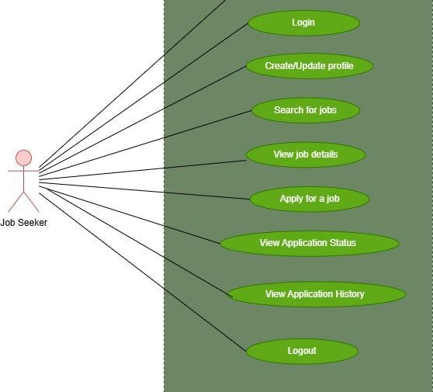

- In Job Seeker use case diagram Job Seeker is the Actor.
- Admin can handle following use cases:
  - Register Account
  - Login
  - Create/Update Profile
  - Search for Jobs
  - View Job details
  - Apply for a Job
  - View Application Status
  - View Application History
  - Logout
- Employer (Recruiter) :

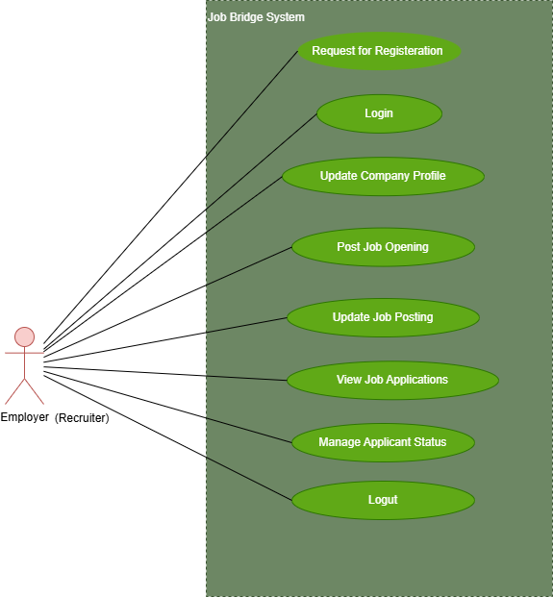

- In Employer (Recruiter) use case diagram Employer (Recruiter) is the Actor.
- Admin can handle following use cases:
  - Request for Registration
  - Login
  - Update Company Profile
  - Post Job Opening
  - Update Job Opening
  - View Job Application
  - Manage Applicant Status
  - Logout
- Admin :

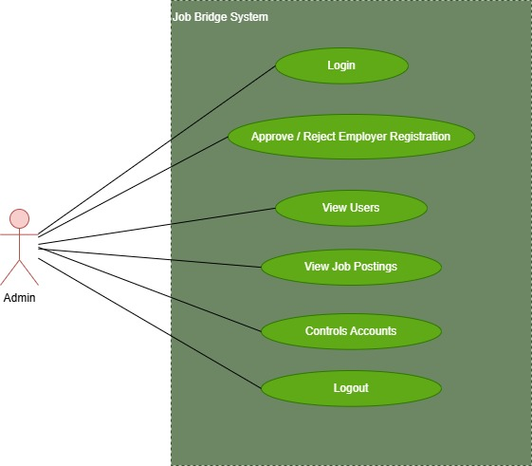

- In Admin use case diagram Admin is the Actor.
- Admin can handle following use cases:
  - Login
  - Approve / Reject Employer Registration
  - View Users
  - View Job Postings
  - Controls Account
  - Logout.

